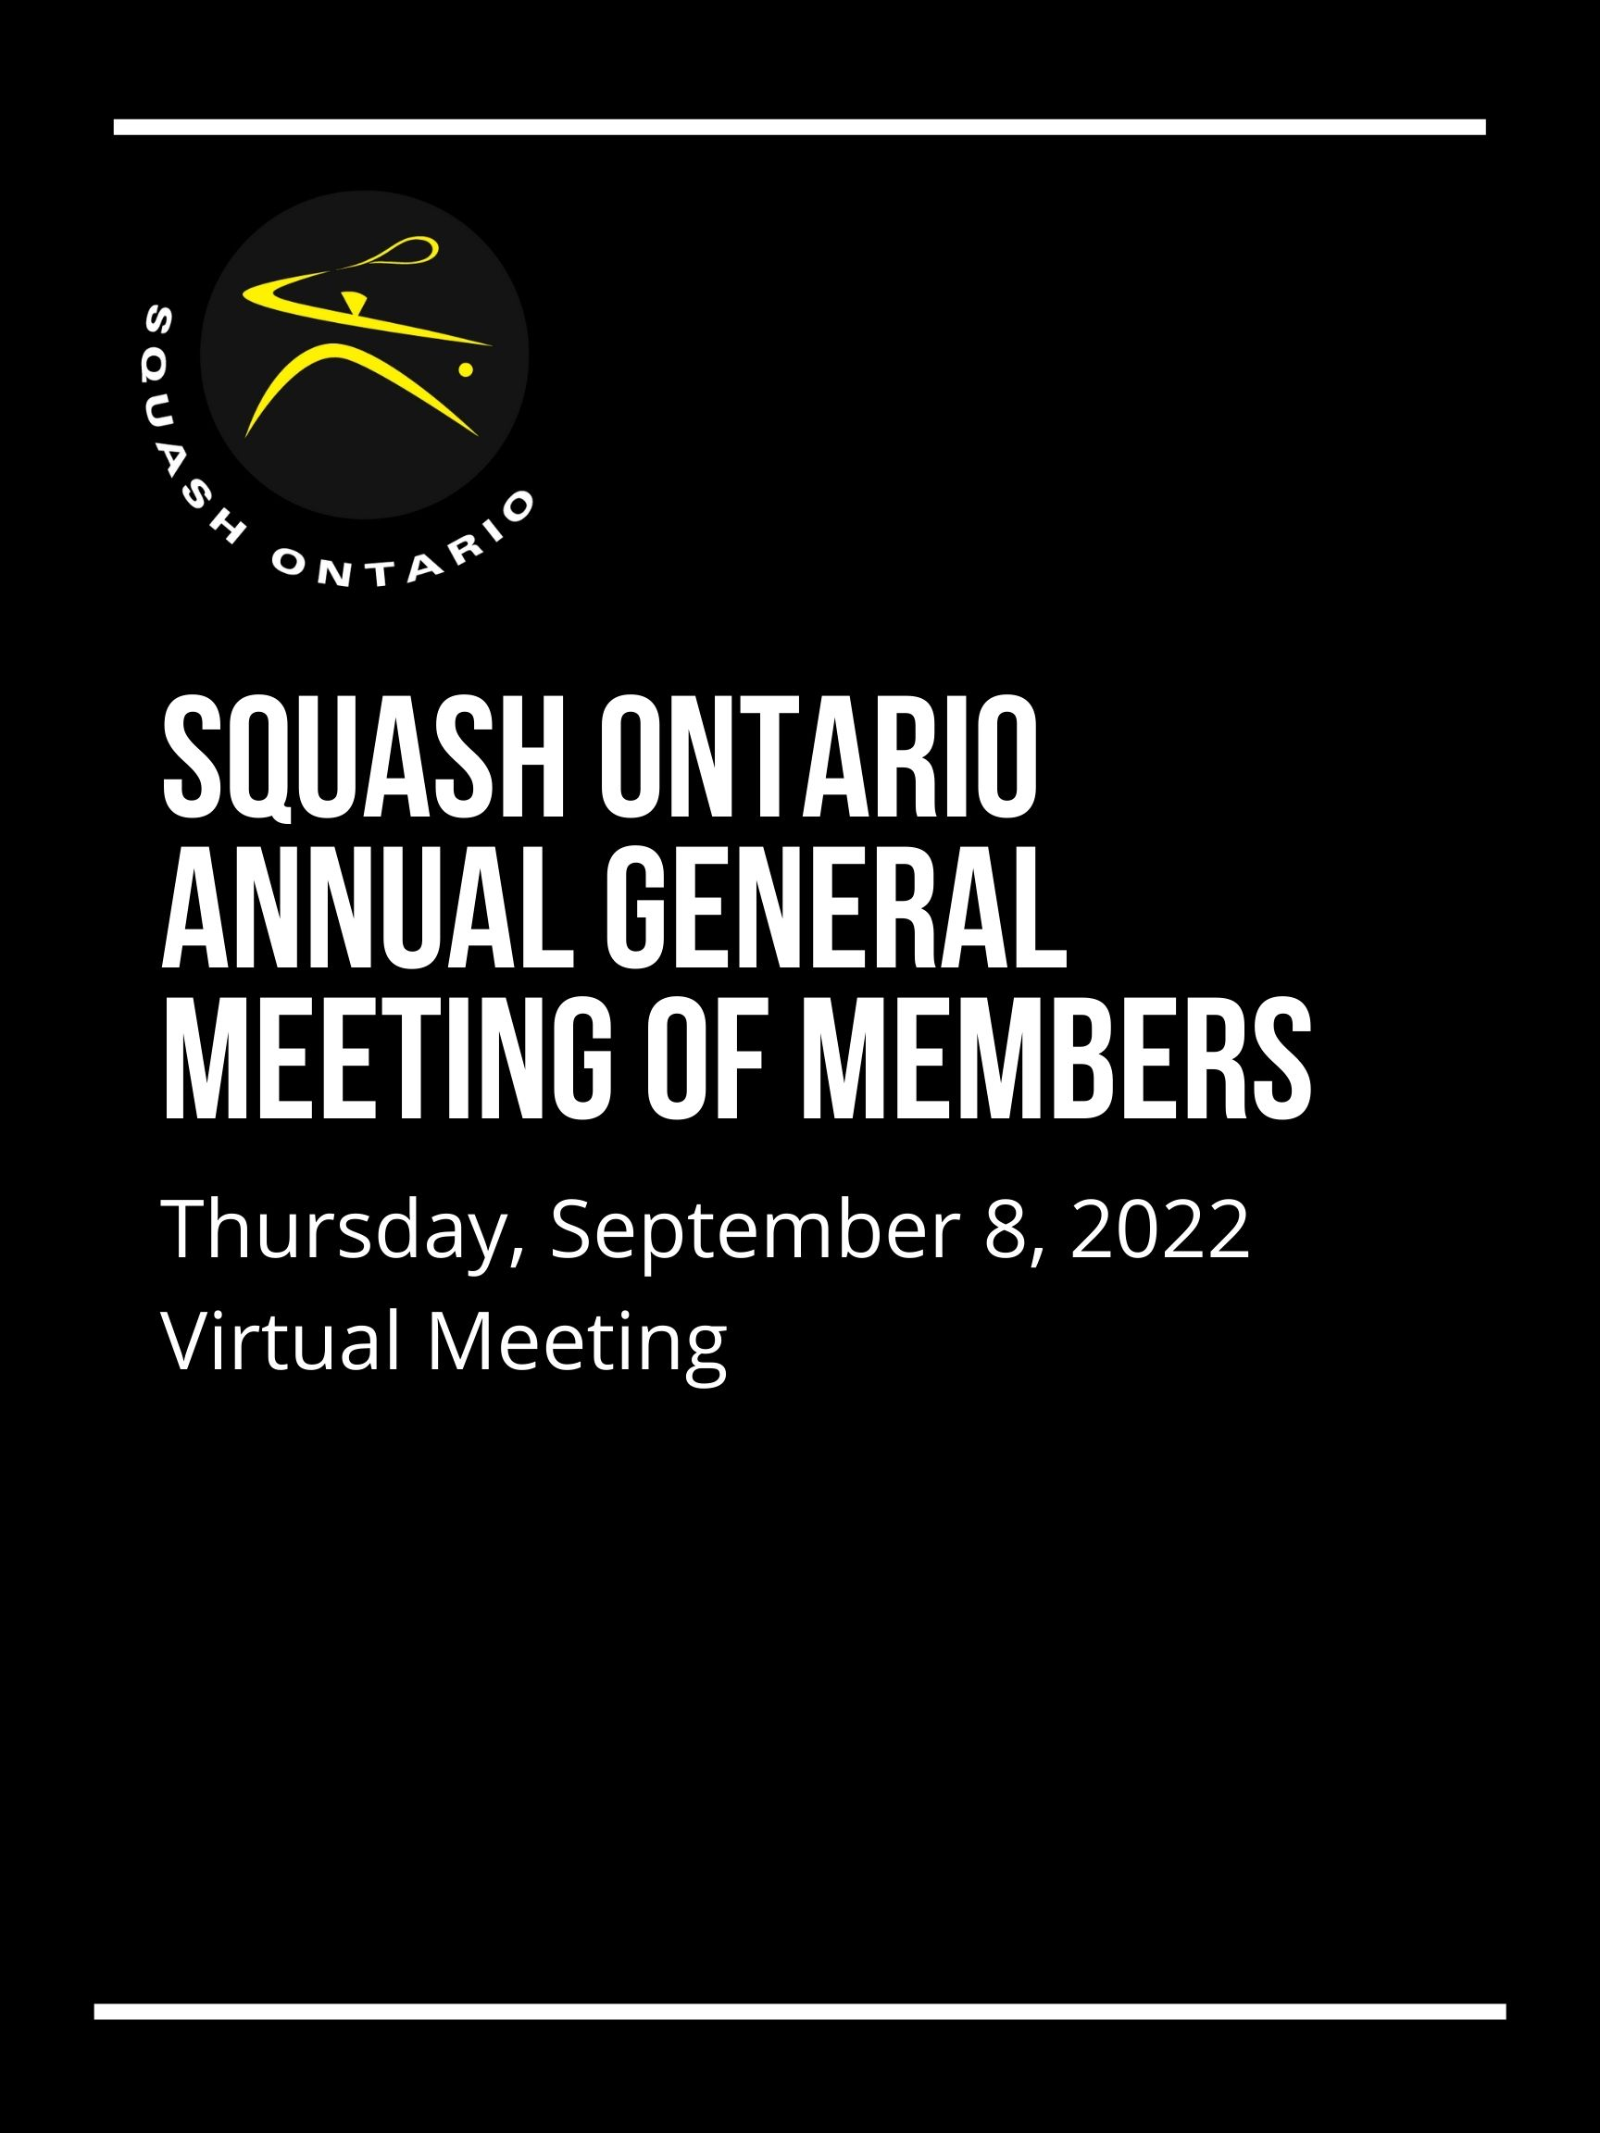

ABOUT SQUASH ONTARIO
Squash Ontario is a not-for-profit amateur sport organization responsible for squash within the province of Ontario. It was formed in 1976, and is recognized by the Ministry of Tourism, Culture and Sport as the Provincial Sport Organization (PSO) for squash in Ontario. We are responsible for delivering programming province-wide to influence the development of players, coaches, officials, and volunteers.

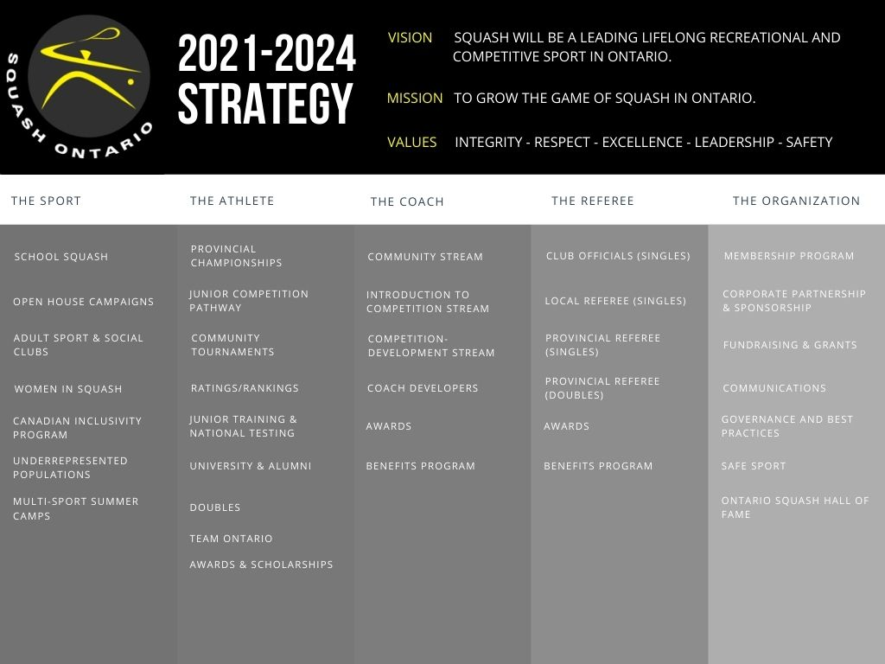

Table of Contents
Schedule Page 3
Annual General Meeting Agenda Page 4

Report from the Board of Directors Page 5

Report from the Executive Director Page 7

Report from the Director of Finance Page 8

Award Recipients from the 2021-2022 Season Page 10

Voting Members of Squash Ontario Page 12

SCHEDULE
9:15 a.m. Log in & vote count
9:30 a.m. Annual General Meeting of Members
10:30 a.m. – 12:15 p.m. Squash Club Presentations
These presentations will count towards professional development points for any Certified Coaches who attend.
- Introducing Squash 57 – Presented by Lolly Gillen (WSF Squash 57 Commission)
  - 10:30 am – 11:30 am
  - Recommended for club pros and management who want to learn more about what Squash 57 is and how it could benefit your club!
- Running a Tournament in Club Locker– Lauren Sachvie
  - 11:45 am – 12:30 pm
  - Recommended for new tournament chairs or those who require a Club Locker refresher. We will go over many topics including entering results, editing draws and times and how to work in admin mode.

Discounted virtual NCCP courses will run in the weeks following the AGM. For more information, see our website event calendar or register below. Limited spaces available!
Planning a Practice - required for Coaching Foundations certification
DATE: Friday, September 09, 2022
TIME: 10:00AM - 3:30PM
COST: $15 plus HST for Ontario Squash players and coaches (typical cost is $90.00)
LINK TO REGISTER: https://clublocker.com/tournaments/14126/info

Teaching and Learning - required for Intermediate Instructor certification
DATE: Monday, September 12, 2022
TIME: 10:00AM - 3:00PM
COST: $15 plus HST for Ontario Squash players and coaches (typical cost is $85.00)
LINK TO REGISTER: https://clublocker.com/tournaments/14127/info

2022 SQUASH ONTARIO ANNUAL GENERAL MEETING AGENDA
September 8, 2022, 9:30 a.m.

Call to order at 9:30 a.m.
Welcome address from Gordon Campbell, Squash Ontario President
The meeting quorum shall be 63 votes present.
MOTION 1: To waive the reading and approve the minutes of the Annual General Meeting of Members of Squash Ontario held on 9 September 2021 (See the 2021 AGM Minutes here).
2021-22 Report from the Board of Directors, Presented by Gordon Campbell.
2021-22 Executive Director Operations Report, Presented by Lauren Sachvie.
2021- 22 Finance Report, Presented by Brian Arlin.
Presentation of the Financial Statements of the Corporation for the fiscal year ending 31 May 2022 by Brian Arlin, Squash Ontario VP, Finance.
Squash Ontario Financial Statement
MOTION 2: To approve the Financial Statements for the Fiscal Year Ending 31 May 2022
MOTION 3: That Chaggares & Bonhomme is hereby appointed as auditors of Squash Ontario to hold office until a successor is appointed at a remuneration to be fixed by the Directors, the Directors being authorized to fix such remuneration.
Presentation of the slate of nominees for the 2022-2024 Squash Ontario Board of Directors, Presented by Brian Arlin, Chair of the Nominating Committee.
MOTION 4: To approve the slate of nominees for the 2022-2024 Squash Ontario Board of Directors.
Other business.
MOTION 5: To adjourn the 2022 Annual General Meeting of Members

PRESIDENT’S REPORT

First of all, I would like to thank all of you who have made the time to attend this year’s Annual General Meeting. I sincerely hope that this will be the last “virtual” AGM we hold. I recognize that a ZOOM meeting makes it easier for more people to attend, but there is something special about all of us getting together once a year. The recovery from the extended Covid pandemic is in full swing at Squash Ontario and most of the thanks goes to the staff and volunteers at Squash Ontario. But I also want to thank our clubs and coaches for their patience and perseverance during the past two years.
Typically, at the AGM, the President is required to report on the achievements that have occurred for this fiscal year. This year, we are trying something a little different. Our Executive Director, who is closest to the daily grind, will present a review that is based on the operational aspects of the fiscal year.
Unlike last year, there has been renewed activity this year, at least for part of the year. I would like to acknowledge the financial stimulus received both from the Federal and the Provincial Governments. In addition, I would like to thank York University (Glendon Campus) for forgiving our rent throughout this fiscal year. With these contributions we have been able to forgive membership dues and manage the distribution of government funds to the clubs most in need.
From the board standpoint, it has been an interesting year. First, SO selected Lynsey Yates as our Executive Director. Lynsey has been a permanent staff member for some time and was able to step into the role without a hiccup. However, life does go on and Lynsey recently started maternity leave upon the birth of her daughter. In her place, Lauren Sachvie has agreed to assume the interim role of Executive Director. Lauren has also been a valued member of Squash Ontario and her experience has allowed SO to continue the momentum that has been developing over the past six months.
This year, you are being asked to elect four directors, three of whom are standing for re-election. We have been fortunate to attract the quality of candidates that we have.
I’d like to take a moment to introduce our Board, to show my appreciation for everything they have done and the collective experience they bring to the organization.
Brian Arlin has been meticulous and thorough during his tenure as the Vice President, Finance, to ensure financial stability through these unknown pandemic circumstances and in preparation for a return in operations. Brian is an active player at several clubs in the GTA. He has brought new thinking and energy to the Board. Unfortunately, Brian’s work and family commitments have made it impossible for him to continue as a Board member. We wish him the most heartfelt thanks for his contributions and hope that he will find time in the future to return to our Board.
Dan Van Moorsel is the owner of the Maple City Squash Club, a keen Masters player and father to active junior players. He has been able to share much important insight through his experience as a club owner affected by COVID and worked on lobbying the government to ensure that our sport wasn’t left out of the conversation at the Ministry level over the past year.
Leah Desbarres is our resident Head Pro, currently working at CW Racquets in Fergus and she sits on our Junior and Masters Committees. She will be a key advisor when it comes to increasing participation at long standing Masters and Women’s events after too long away from the courts.
Vinit Kudva, our Ottawa region and University squash representative, has played a significant role with the University Squash program during the past year as the Squash Ontario liaison with the Jesters Club and the Squash Ontario staff transition.
Natasha Seth, Natasha has lived and breathed squash since birth and brings valuable experience not only to the Board but also our Gender Equity and Alumni committees as a player, coach, and University program alumni. Natasha is keen to see this sport grow and has offered her help wherever it is needed.
Heather Dart represents a wide range of the squash community in Ontario. She is an active singles & doubles player. She competed for Team Ontario at the Canadian Masters Team Championships in early 2020 after receiving a title in her age group at the Ontario Masters Championships in 2019. By trade, Heather operates a private outpatient physiotherapy and osteopathy practice in Uxbridge, Ontario. Heather has experience sitting on a number of other Committees and Boards.

As you all know the challenges our squash community face today mean job and club status are threatened as we slowly return to the “new normal”. My sincere thanks to the Board as well as to those in attendance today, for all your support.
Again, this past year our COVID-19 Task Force made up of Eric Baldwin, Ralph Shillington, Bree Holt, Dr. Shivinder Jolly, Anis Khan, Dr. Anne Smith, and Dr. Scott Gledhill, have supported Squash Ontario through the ever-changing government restrictions and continuing Covid waves. With each new government update, this group would hurry to digest the new rules to provide a squash specific interpretation and recommendations to keep players and clubs safe. This group represents real leadership, espousing fairness and safety for all our players in these extraordinary times.
As we have slowly emerged from the pandemic, the financial and employment strains have continued to challenge our member clubs. You will hear more of the financial impact shortly from Brian Arlin, but our financial position is stronger than anticipated, which bodes well for the future. Throughout the pandemic, Squash Ontario has continued to support our member clubs and were able to take advantage of government programs that have helped us weather the storm. We now have an ambitious strategy and plan laid out to relaunch and reinvigorate squash in Ontario.
I would like to take this final opportunity to give special thanks to our many partners and individuals that support all we do at Squash Ontario. The provincial squash community is truly a special group of people and we are so fortunate to be able to serve you all. We are indebted to our committee members and volunteers who take the time and energy to give back to our sport.
In closing, Squash Ontario looks forward to supporting the squash player, our clubs, professionals and volunteers as we return to pre-pandemic levels of activity.

Respectively submitted,
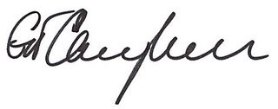

Gordon Campbell, Squash Ontario President

EXECUTIVE DIRECTOR’S REPORT

This past season presented many new challenges to navigate with strict government restrictions being put on fitness facilities, including limited capacity. The majority of our fall 2021 tournaments had to be limited to much smaller 8 person draws with many new protocols to follow.
After being forced to cancel our tournaments from March 2020 – September 2021, Squash Ontario was able to run all our provincial championships and the majority of our junior circuit events during the 2021-2022 season. It is important to note this would not have been possible without the support of our host venues opening up their doors, our wonderful sponsors or dedicated community of squash players!
As expected, we saw a decrease in overall participation numbers and club run sanctioned events, especially in the first half of the season. It is important to note Squash Ontario saw an increase in junior female participation in our Grand Prix circuit events for the first time in years, which we look to build on this coming season. Our junior talent identification camps were put on hold but will be returning this fall.
Some highlights from this year included another successful Charity Golf Tournament, which was sold out and raised over $18,000 for junior squash. During July 2022, Squash Ontario partnered with COSTI and Maria Toorpakai’s foundation to run two weeks of squash and cricket camps for young female refugees from Afghanistan at Urban Squash Toronto. With thanks to a Jumpstart grant, we were able to provide this camp free of charge for the girls.
High Performance highlights include six Ontario players being crowned Canadian Champions at the 2022 Vancouver nationals, three Ontario players crowned Canadian Junior Champions at the 2022 Victoria nationals and juniors Syan Singh, Alex Yuzpe and coach Robin Clarke represented Canada at the World Junior Championships in France, with the team finishing in 10th place. Ontario players Hollie Naughton and Nick Sachvie were named to the 2022 Commonwealth Games team. Hollie made history by being the first Canadian woman in the finals, finishing with a silver medal in singles and taking out the World #5 along the way! Despite a late start and a mid season lockdown, Squash Ontario crowned over 100 new Provincial Champions and ran 11 Provincial Championships.
Operationally, Squash Ontario has recently welcomed two new full time staff members. Tania Kumar joins us as the Programs Coordinator and will focus on our Coaching and Officiating programs, along with member club relations. Zoraiz Zakir is our Competitions Coordinator and will be the point person for all things tournaments and events. Lynsey Yates recently welcomed a beautiful baby girl and will remain on maternity leave until June 2023. In the meantime, I will act as the interim Executive Director. Our team is looking forward to the year ahead and we hope to see you all in person very soon!

Respectfully Submitted,
Lauren Sachvie
Executive Director, Squash Ontario

FINANCE REPORT
Our recently completed fiscal year ended May 31, 2022, although still impacted by COVID-19, finally started to resemble a normalized financial year. The year saw squash operations spring back to life along with the related familiar revenues and expenses from memberships, tournaments, programs, and fundraising, although these were somewhat muted due to COVID-19 impacts. By the same token, we continued to receive government support in the form of grants and wage subsidies, referred to in more detail below, much of which were COVID-19 related. Overall and as you can see from the accompanying financial statements, our financial results and position remained strong this year with positive net income and a growing net asset surplus.
On the revenue side, all program and event revenues increased due to operations returning from a prior year where there was virtually no squash. This includes tournaments, coaching clinics, league sanctioning, and fundraising through sponsorships and donations. Individual and Club Membership revenues also increased from the prior year, again thanks to operations returning.
More notably, revenues were mostly lower as compared to pre-pandemic normalized revenues. Club Membership and Individual Membership revenues were both 13% lower as a result of club closures, regional leagues not yet returned, and limited tournament participation. Overall tournament revenues were down 40% from pre-pandemic levels. This is attributed to fewer sanctioned events, restricted draw sizes in the Fall season, and juggling a full January 2022 lockdown with many COVID-19 related dropouts throughout the winter and spring.
Our government grant activity was strong this year. We received the Provincial Government Community Sport Club Funding which was flowed through to support 44 member clubs who opted in for a total of $314,300. We received $54,000 provincial government COVID relief support. We received $23,397 for the Return of the Quest for Gold program which directly funds top Ontario athletes. Finally, we received $48,531 in individual grants to support specific outreach and athlete development programs.
Moving over to expenses, all program and event expenses also increased from prior year due to the return of our operations (with some restrictions/limits such as Regional Athlete Training and outreach). These include clinics, tournaments, and athlete development programming such as school squash, Team Ontario training, University squash and junior awards programs.
Special Event expenses increased this year with the bi-annual Ontario Squash Hall of Fame Induction Ceremony.
Payroll expenses increased since we were operating understaffed in the prior year. With Lynsey Yates moving into the Executive Director role at the height of covid, her previous role remained vacant until January 2022. Leading up to January 2022, staffing including contract and part time employees which were often covered by government salary grants, and wage subsidies continued until September 2021.
Squash Ontario continued to receive full rent relief due to lease and renovation negotiations, and rent is expected to return in September 2022.
As a result of the above, Squash Ontario had a Net Income of $96,855 which overall strengthened Net Assets from $230,075 as at May 31, 2021 to $326,930 as at May 31, 2022.
In summary, Squash Ontario is in a strong financial position which will help the organization return to fully normalized operations this upcoming year as well as reinvest in much needed programming to help us bounce back from two and a half years of COVID-19 impacts, and to ultimately grow the sport in Ontario. With a healthy profit from the past two years, the Board and staff are looking to new ideas and initiatives on how we can reinvest the profits back into the community. We are optimistic about a full return of events beginning in September 2022, with more regional athlete development programs returning, Team Ontario training and competitions, and a full event schedule with unrestricted draw sizes.
My report would not be complete without recognizing the contributions of Lynsey Yates and Lauren Sachvie who have been instrumental in the financial operations of the organization beyond their day-to-day Squash Ontario duties. This includes avidly seeking out and applying for our government grants and keeping accurate and meaningful books and records of the Organization. Lynsey and Lauren have both developed a sound financial acumen and I greatly appreciate their support
Respectfully Submitted,

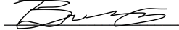

Brian Arlin Squash Ontario VP, Finance

2022 SQUASH ONTARIO RECOGNITION AWARDS

Special Achievement Award
Presented to those who have made very significant contributions to the game of squash, not only in Ontario but also on a national and international basis. It is Squash Ontario’s highest and most prestigious honour.
Hollie Naughton
The board would like to recognize Hollie Naughton (Oakville, ON) for making history as the first Canadian woman to make it to the Commonwealth Games final. This summer Hollie captured the silver medal after defeating the top seed in the semi-finals. She has been climbing up the PSA rankings year after year and currently sits in the top 20 in the world!

Outstanding Achievement Award
The game of squash thrives when there is growth at the local and regional levels. The Outstanding Achievement Awards program was created by the Board of Directors to recognize the contributions made by volunteers, corporations, officials, coaches and players at all levels of the game.

Jay Nash
For his ongoing commitment to organizing and hosting the Nash Cup Amateur & PSA events in London. Going into it’s 14th year, the Nash Cup provides a platform for Canada’s top players to showcase their talents on home soil against players from around the world. In addition to the PSA draw, Jay runs a large amateur event that is the highlight of many players’ season!

Peter Hall
Aside from a 5-decade formidable record on the doubles court, which includes numerous Ontario, Canadian and US titles, Peter has made an extraordinary contribution to the Ontario Squash Hall of Fame. In less than 10 years, he has almost single handedly raised close to $50,000 for the Hall of Fame. He has acted as MC at the last 4 induction ceremonies, preparing for his role with care and determination to do the inductee justice.

Ray Kerslake
Ray is extremely passionate about squash and has been playing for 45+ years! As a builder of the sport, Ray was one of the founders of the Peterborough Squash Club. He has coached countless numbers of juniors and adults in his area for the past 40 years. In addition to chairing many squash tournaments, he took over as lead of the Kawartha Squash League in 2010. As an accomplished player, Ray is still very active on the tournaments scene.

Barbara Cooper Award
The Barbara Cooper Award will be awarded each year to an individual in Ontario who has over the years built, promoted and enhanced the game of women’s squash. This person exhibits fair play. The individual should demonstrate leadership and achievement in both their competitive and social life. This person is an inspirational role model for others to follow.
Alison Le Ber
Alison has been a huge recruiter and influence in women’s squash both at the Pickering Squash Club and throughout the province. She recently won a grant and supported the Women in Squash encouragement program where she helped introduce over 50 new women to the sport. Alison is huge supporter of the T&D league both as a volunteer and a player. She always supports the women’s team tournaments throughout the city and works very hard as a volunteer to coach beginner programs at her home club in Pickering. Her love for the game is very obvious as she is always willing to help and has a huge smile on her face the minute she walks into a squash club!

Simon Warder Officiating Award
In the memory of Simon Warder, this award is given to an Ontario official who has earned the respect of the players and their peers; who seeks opportunities to upgrade their skills; who is committed to mentoring others, and who represents the game and profession of officiating with integrity and fairness.

Darrin Manley
Many of his peers agree Darrin is the perfect recipient for this award. He is extremely keen, hard working and has been a great addition to our amazing group of Ontario officials. Over the past few years, Darrin has acted as Tournament Referee for many Provincial and National events. His knowledge of the sport shines through his excellent call making and is respected amongst his peers, tournament chairs and any players who are lucky enough to encounter him.

Robert Brooks Squash Scholarship
The Robert Brooks Squash Scholarship offers a financial contribution of $1,000.00 to graduating Ontario secondary school students who have excelled in both school and squash. The successful recipients of the Scholarship will be individuals (one male and one female) who have continually shown passion and sportsmanship, both on and off the court, and who are entering higher education (college or university). Successful recipients will have demonstrated a long-time commitment to the programming of Squash Ontario.

Amal Izhar
Amal Izhar is one of Ontario's top female players with a very impressive resume. A few successes from this past year include winning her first PSA tournament - 2022 Quebec Open, receiving the Jim Mason Fair Play Award and representing Team Canada at the Pan American Squash Championships in Guatemala. In the fall, Amal will be attending the prestigious Columbia University in New York City is planning on studying Neuroscience and Behavior, while playing on their women's squash team.
Josh Kay
Josh Kay joined the Squash Ontario community from a very young age and some career highlights include winning the Boys Under 19 Provincial Championship this past season, 2020 Junior Doubles Champion and multiple Gold tournament wins. He also captained his team to victory at the Jim Mason Cup high school event. Josh will be attending the University of Western Ontario in the fall to study Business and plans to play on their men's squash team.

VOTING MEMBERS OF SQUASH ONTARIO
The following member clubs will have voting privileges at the 2022 Squash Ontario Annual Meeting which is being held virtually on Thursday, September 8th, 2022 at 9:30 a.m. Each member facility will have one vote equal to the number of its paid-up courts to Squash Ontario as at fiscal year end, 31 May 2022.

Northwestern Ontario Member Facilities

Canada Games Complex | Thunder Bay | 2
The Hunt Club Squash and Yoga | North Bay | 3
Timmins Tennis & Squash Club | Timmins | 1
Waterfront Pool/Fitness Centre | Temiskaming | 1
4 Voting Members |  | 7

Niagara Region Member Facilities

Brock University | St. Catharines | 1
Ridley College | St. Catharines | 1
The Club at White Oaks | Niagara-on-the-Lake | 8
YMCA St. Catharines | St. Catharines | 1
4 Voting Members |  | 11

Ottawa & District Member Facilities

Deep River Curling & Squash Club | Deep River | 2
Nepean Squash Racquets Club | Nepean | 2
RA Squash Club | Ottawa | 2
Smiths Falls Squash Club | Smiths Falls | 2
Squash Gloucester | Ottawa | 2
University of Ottawa | Ottawa | 1
Wallace Squash | Ottawa | 4
7 Voting Members |  | 15

Southwestern Ontario Member Facilities

London Fitness Forum | London | 3
London Squash &Fitness Club | London | 5
Maple City Squash Club | Chatham | 2
Movati London Athletic Club | London | 3
North London Optimist Community Centre | London | 2
Of Courts | London | 4
Sarnia Riding Club | Sarnia | 2
Windsor Squash & Fitness Club | Windsor | 6
University of Western | London | 1
9 Voting Members |  | 28

Western Ontario Member Facilities

Ancaster Sports Centre | Ancaster | 2
Cedar Springs Health, Racquet & Sports Club | Burlington | 9
CW Racquets & Fitness | Fergus | 3
Georgetown Racquet Club | Georgetown | 3
Greystone Racquet Club | Waterloo | 6
Glen Abbey Community Centre | Oakville | 2
Kitchener-Waterloo Racquet Club | Kitchener | 3
Lakeshore Recreation | Goderich | 1
Listowel Squash Club | Listowel | 1
McMaster University | Hamilton | 1
The Oakville Club | Oakville | 4
University of Guelph Squash Club | Guelph | 1
University of Waterloo Squash Club | Waterloo | 1
Wilfred Laurier University | Waterloo | 1
YMCA of Cambridge | Cambridge | 2
YMCA of Three Rivers | Guelph | 2
16 Voting Members |  | 42

Central Ontario Member Facilities

Ajax Squash Club | Ajax | 2
Brockville Squash Club | Brockville | 2
Campbellford & District Curling & Racquet Club | Campbellford | 2
Chestnut Hill Developments Recreation Complex | Pickering | 2
Clarington Squash Club | Bowmanville | 2
Kingston Garrison Squash Club | Kingston | 2
Lindsay Recreation Complex | Lindsay | 2
Peterborough Squash Club | Peterborough | 2
Prince Edward County Aquatic Centre | Picton | 2
Queen’s University Squash Club | Kingston | 1
Trinity College School | Port Hope | 1
YMCA Kingston | Kingston | 2
12 Voting Members |  | 22

Toronto- Mississauga Member Facilities

Adelaide Club | Toronto | 3
Badminton & Racquet Club | Toronto | 6
Balmy Beach Club | Toronto | 2
Columbus Centre | Toronto | 2
Crescent Town Squash Club | Toronto | 2
Dixie Squash Club | Mississauga | 2
Glendon Athletic Club | Toronto | 4
Granite Club | Toronto | 7
Mayfair Lakeshore | Toronto | 10
Meadowvale Community Centre | Mississauga | 2
Mississauga Lifetime Athletic | Mississauga | 4
Ontario Racquet Club | Mississauga | 7
Parkview Squash Club | Toronto | 2
Royal Canadian Yacht Club | Toronto | 6
Squashabout at Dunfield | Toronto | 5
Ten X Toronto | Toronto | 3
The Cambridge Club | Toronto | 3
Toronto Athletic Club | Toronto | 4
Toronto Cricket, Skating & Curling Club | Toronto | 9
Toronto Lawn Tennis Club | Toronto | 4
Toronto Racquet Club | Toronto | 3
University of Toronto | Toronto | 1
Urban Squash Toronto | Toronto | 1
YMCA West End | Toronto | 2
York University | Toronto | 1
25 Voting Members |  | 95

York North Member Facilities

Aurora Family Leisure Complex | Aurora | 2
MVMT - Fitness & Performance | Collingwood | 3
Headwaters Racquet Club | Orangeville | 4
Lemonade Collective | Blue Mountains | 1
Master Squash Key Club | Newmarket | 1
Mayfair Parkway | Markham | 9
Parkway Health and Racquet Club | Markham | 4
Richmond Hill Squash Club | Richmond Hill | 5
St. Andrew’s College | Aurora | 2
9 Voting Members |  | 31
86 Voting Members |  | TOTAL PAID COURTS: 251  QUORUM: 63 VOTES

